1A.

> colMeans(USArrests)

Murder Assault UrbanPop Rape

7.788 170.760 65.540 21.232

> median(USArrests$Murder)

[1] 7.25

> median(USArrests$Assault)

[1] 159

> median(USArrests$UrbanPop)

[1] 66

> median(USArrests$Rape)

[1] 20.1

> var(USArrests$Murde)

[1] 18.97047

> var(USArrests$Assault)

[1] 6945.166

> var(USArrests$UrbanPop)

[1] 209.5188

> var(USArrests$Rape)

[1] 87.72916

> sd(USArrests$Murder)

[1] 4.35551

> sd(USArrests$Assault)

[1] 83.33766

> sd(USArrests$UrbanPop)

[1] 14.47476

> sd(USArrests$Rape)

[1] 9.366385

> IQR(USArrests$Murder)

[1] 7.175

> IQR(USArrests$Assault)

[1] 140

> IQR(USArrests$UrbanPop)

[1] 23.25

>

> IQR(USArrests$Rape

+

+ )

[1] 11.1

1B.

> library(psych)

> skew(USArrests$Murder)

[1] 0.3706342

> skew(USArrests$Assault)

[1] 0.2205325

> skew(USArrests$UrbanPop)

[1] -0.2126297

> skew(USArrests$Rape)

[1] 0.7537694

> kurtosi(USArrests$Murder)

[1] -0.9492304

> kurtosi(USArrests$Assault)

[1] -1.145487

> kurtosi(USArrests$UrbanPop)

[1] -0.871955

> kurtosi(USArrests$Rape)

[1] 0.07510264

1C.

> hist(USArrests$Murder)

> hist(USArrests$Assault)

> hist(USArrests$UrbanPop)

> hist(USArrests$Rape)

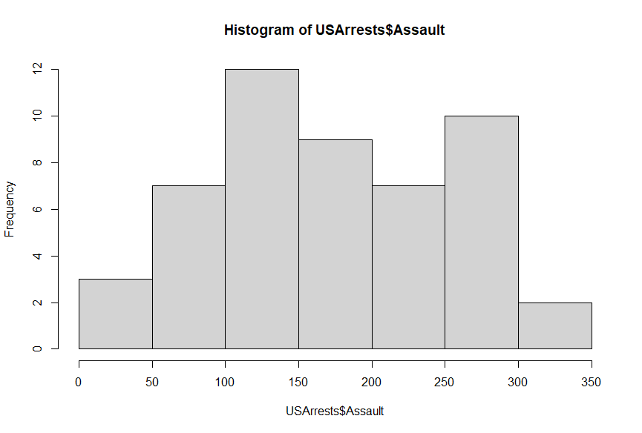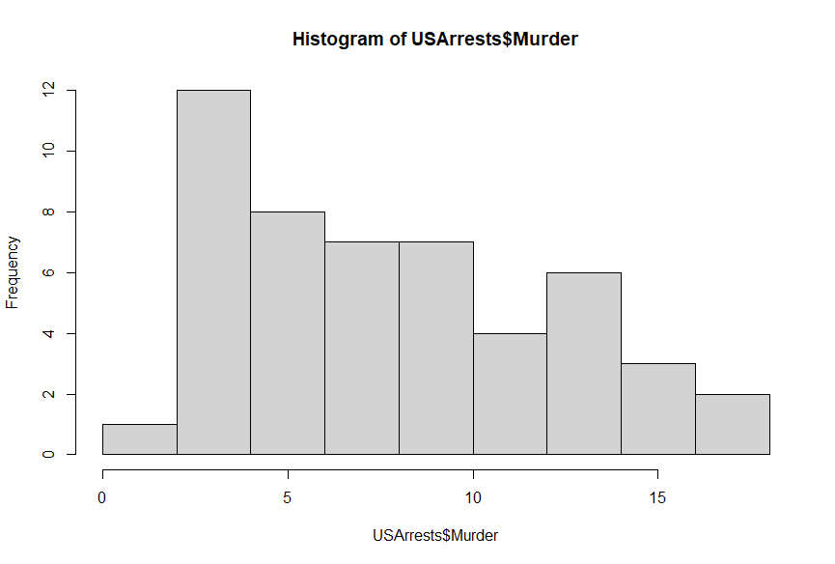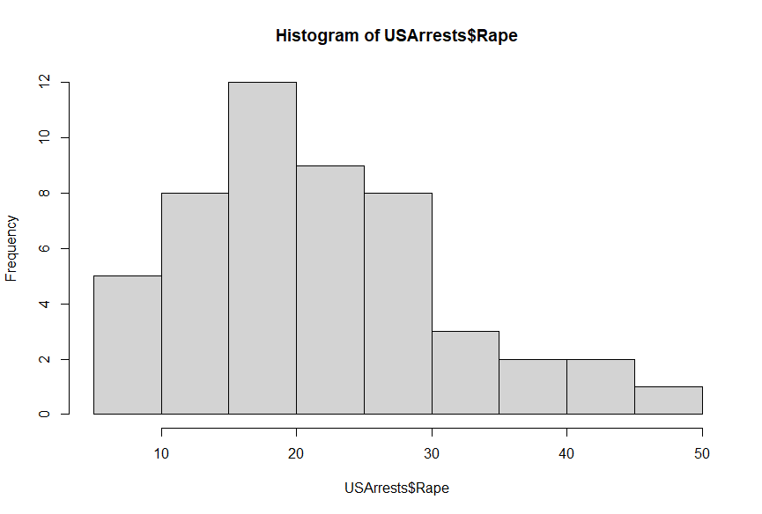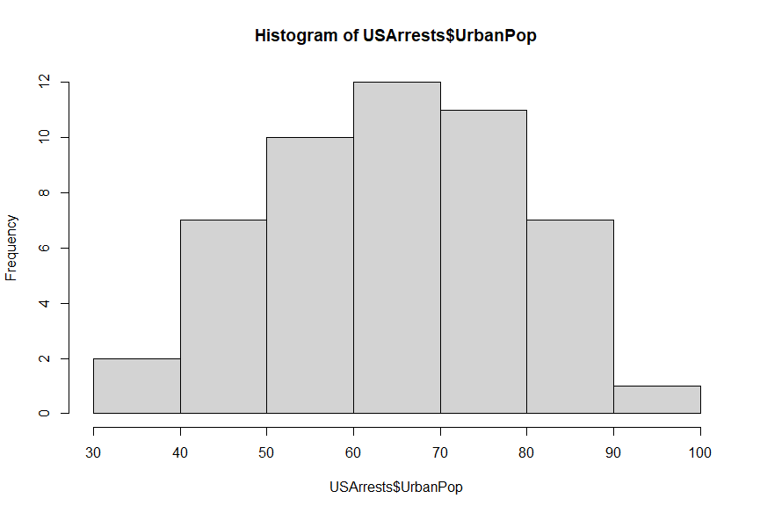

1D.  
> cor(x = USArrests,method = "spearman")

Murder Assault UrbanPop Rape

Murder 1.0000000 0.8172735 0.1067163 0.6794265

Assault 0.8172735 1.0000000 0.2752133 0.7143681

UrbanPop 0.1067163 0.2752133 1.0000000 0.4381068

Rape 0.6794265 0.7143681 0.4381068 1.0000000

> cor(x = USArrests,method = "pearson")

Murder Assault UrbanPop Rape

Murder 1.00000000 0.8018733 0.06957262 0.5635788

Assault 0.80187331 1.0000000 0.25887170 0.6652412

UrbanPop 0.06957262 0.2588717 1.00000000 0.4113412

Rape 0.56357883 0.6652412 0.41134124 1.0000000

2A.

> state.x77=as.data.frame(state.x77)

> class(state.x77)

[1] "data.frame”

2B. (wasn’t sure which one so i did both)

> summary(state.x77)

Population Income Illiteracy Life Exp Murder HS Grad Frost

Min. : 365 Min. :3098 Min. :0.500 Min. :67.96 Min. : 1.400 Min. :37.80 Min. : 0.00

1st Qu.: 1080 1st Qu.:3993 1st Qu.:0.625 1st Qu.:70.12 1st Qu.: 4.350 1st Qu.:48.05 1st Qu.: 66.25

Median : 2838 Median :4519 Median :0.950 Median :70.67 Median : 6.850 Median :53.25 Median :114.50

Mean : 4246 Mean :4436 Mean :1.170 Mean :70.88 Mean : 7.378 Mean :53.11 Mean :104.46

3rd Qu.: 4968 3rd Qu.:4814 3rd Qu.:1.575 3rd Qu.:71.89 3rd Qu.:10.675 3rd Qu.:59.15 3rd Qu.:139.75

Max. :21198 Max. :6315 Max. :2.800 Max. :73.60 Max. :15.100 Max. :67.30 Max. :188.00

Area

Min. : 1049

1st Qu.: 36985

Median : 54277

Mean : 70736

3rd Qu.: 81163

Max. :566432

> describe(state.x77)

vars n mean sd median trimmed mad min max range skew kurtosis se

Population 1 50 4246.42 4464.49 2838.50 3384.28 2890.33 365.00 21198.0 20833.00 1.92 3.75 631.37

Income 2 50 4435.80 614.47 4519.00 4430.08 581.18 3098.00 6315.0 3217.00 0.20 0.24 86.90

Illiteracy 3 50 1.17 0.61 0.95 1.10 0.52 0.50 2.8 2.30 0.82 -0.47 0.09

Life Exp 4 50 70.88 1.34 70.67 70.92 1.54 67.96 73.6 5.64 -0.15 -0.67 0.19

Murder 5 50 7.38 3.69 6.85 7.30 5.19 1.40 15.1 13.70 0.13 -1.21 0.52

HS Grad 6 50 53.11 8.08 53.25 53.34 8.60 37.80 67.3 29.50 -0.32 -0.88 1.14

Frost 7 50 104.46 51.98 114.50 106.80 53.37 0.00 188.0 188.00 -0.37 -0.94 7.35

Area 8 50 70735.88 85327.30 54277.00 56575.72 35144.29 1049.00 566432.0 565383.00 4.10 20.39 12067.10

2C.

install.packages("Hmisc")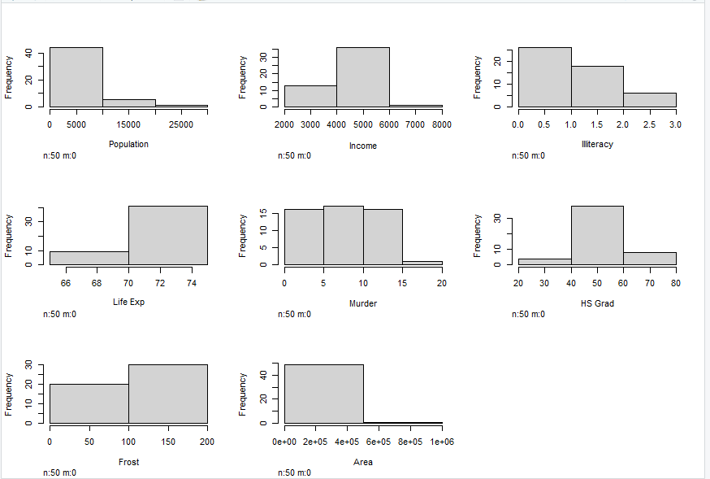

> library(Hmisc

> hist.data.frame(state.x77)

2D.

> cor(x = state.x77,method = "pearson")

Population Income Illiteracy Life Exp Murder HS Grad Frost Area

Population 1.00000000 0.2082276 0.10762237 -0.06805195 0.3436428 -0.09848975 -0.3321525 0.02254384

Income 0.20822756 1.0000000 -0.43707519 0.34025534 -0.2300776 0.61993232 0.2262822 0.36331544

Illiteracy 0.10762237 -0.4370752 1.00000000 -0.58847793 0.7029752 -0.65718861 -0.6719470 0.07726113

Life Exp -0.06805195 0.3402553 -0.58847793 1.00000000 -0.7808458 0.58221620 0.2620680 -0.10733194

Murder 0.34364275 -0.2300776 0.70297520 -0.78084575 1.0000000 -0.48797102 -0.5388834 0.22839021

HS Grad -0.09848975 0.6199323 -0.65718861 0.58221620 -0.4879710 1.00000000 0.3667797 0.33354187

Frost -0.33215245 0.2262822 -0.67194697 0.26206801 -0.5388834 0.36677970 1.0000000 0.05922910

Area 0.02254384 0.3633154 0.07726113 -0.10733194 0.2283902 0.33354187 0.0592291 1.00000000

> cor(x = state.x77,method = "spearman")

Population Income Illiteracy Life Exp Murder HS Grad Frost Area

Population 1.0000000 0.12460984 0.3130496 -0.1040171 0.3457401 -0.3833649 -0.4588526 -0.12067227

Income 0.1246098 1.00000000 -0.3145948 0.3241050 -0.2174623 0.5104809 0.1968638 0.05709484

Illiteracy 0.3130496 -0.31459482 1.0000000 -0.5553735 0.6723592 -0.6545396 -0.6831936 -0.25037208

Life Exp -0.1040171 0.32410498 -0.5553735 1.0000000 -0.7802406 0.5239410 0.2983910 0.12750018

Murder 0.3457401 -0.21746230 0.6723592 -0.7802406 1.0000000 -0.4367330 -0.5438432 0.10642590

HS Grad -0.3833649 0.51048095 -0.6545396 0.5239410 -0.4367330 1.0000000 0.3985351 0.43897520

Frost -0.4588526 0.19686382 -0.6831936 0.2983910 -0.5438432 0.3985351 1.0000000 0.11228778

Area

The hs_grad to murder relationship is interesting, although i cannot explain why it is like that.

2E.  
> row.names(state.x77)[which.max(state.x77$Population)]

[1] "California"

> row.names(state.x77)[which.min(state.x77$Population)]

[1] "Alaska"

> row.names(state.x77)[which.max(state.x77$Income)]

[1] "Alaska"

> row.names(state.x77)[which.min(state.x77$Income)]

[1] "Mississippi"

> row.names(state.x77)[which.max(state.x77$Illiteracy)]

[1] "Louisiana"

> row.names(state.x77)[which.min(state.x77$Illiteracy)]

[1] "Iowa"

> row.names(state.x77)[which.max(state.x77$`Life Exp`)]

[1] "Hawaii"

> row.names(state.x77)[which.min(state.x77$`Life Exp`)]

[1] "South Carolina"

> row.names(state.x77)[which.max(state.x77$Murder)]

[1] "Alabama"

> row.names(state.x77)[which.min(state.x77$Murder)]

[1] "North Dakota"

> row.names(state.x77)[which.max(state.x77$`HS Grad`)]

[1] "Utah"

> row.names(state.x77)[which.min(state.x77$`HS Grad`)]

[1] "South Carolina"

> row.names(state.x77)[which.max(state.x77$Frost)]

[1] "Nevada"

> row.names(state.x77)[which.min(state.x77$Frost)]

[1] "Hawaii"

> row.names(state.x77)[which.max(state.x77$Area)]

[1] "Alaska"

> row.names(state.x77)[which.min(state.x77$Area)]

[1] "Rhode Island"